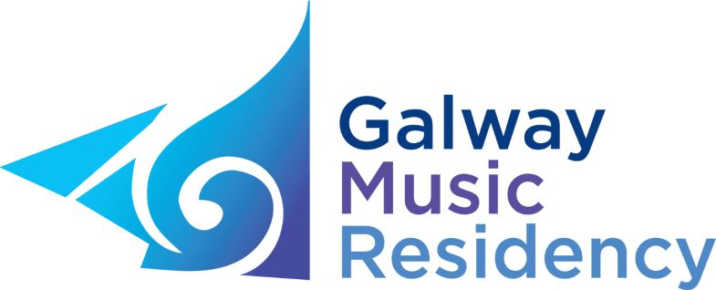

APPRENTICE ENSEMBLE PROGRAMME

The Galway Music Residency (GMR) is inviting applications from chamber ensembles for its Apprentice Ensemble Programme 2020/21.
Now in its 15th year, the Apprentice Ensemble Programme is rooted in GMR’s commitment to community and education projects, and provides advanced instrumental students and young professionals an opportunity to further their experience of ensemble playing. During their time on the programme, September 2020 – May 2021, the ensemble(s) will be mentored and advised on a monthly basis by members of the Galway ConTempo Quartet.

Performance Opportunities
A significant part of the programme is the performance opportunities provided to participants. The ensemble(s) will take part in two core performances during their time on the programme: a Winter Recital in January 2021 and a Final Concert in May 2021. The ensemble(s) may also be offered a number of other performance opportunities as they arise.

Continuing in 2020/21
GMR is continuing its partnership with Music for Galway, providing the selected ensemble(s) an opportunity to attend master classes with visiting artists featured in the Music for Galway concert series (www.musicforgalway.ie).

Contemporary Repertoire
There is a particular focus on exploring the works of Irish composers and, with this in mind, the ensemble(s) will prepare a piece from the Contemporary Music Centre’s catalogue during the programme.

Who can apply?
The programme is open to existing groups wanting to further enrich their experience of ensemble playing. It may also suit established musicians or teachers coming together as an ensemble for the first time.

Also eligible to apply are junior ensembles based in the West of Ireland; a junior ensemble would consist of participants of 19 years and younger who have not yet begun their third level music studies who live in Galway city or county.

Any combination of instruments is welcome to apply; over the years GMR has hosted many different groupings, including a cello duo, two saxophone quartets, a flute and harp duo, a guitar quartet, flute & voice duo, a baroque ensemble, etc.

Priority will be given to those who can best demonstrate that this programme will be of significant value to them in their current and future career/musical development.
Applicants must be able to commit for the full year (Sep 20 – May 21) including a number of set workshops and performances, which will take place in Galway.

How to apply?
To apply, please complete the application form available here or from www.thegalwaymusicresidency.ie. Closing date for applications is 12 noon on Friday 3rd April 2020 with auditions scheduled in Galway during the week beginning 20th April.

For further information please contact Julie Seagrave, Admin; tel: +353 91 586706 or email julie@thegalwaymusicresidency.ie

___________________________________________________________________________

It is one of the best things a young musician in Ireland could do […] to keep developing performance skills and confidence.
- Feedback from Apprentice Ensemble Programme participant, April 2016

